**API TESTING**

**Tester Name** : Rubel Hosain

**User API Url** : https://gorest.co.in/public/v2/users

**Used Tool For Test** : Postman

**Used For Report** : Newman

**Date**  : 22-01-2023

**This is actually API test summary report**

**Test Description:**

I used a demo API from the gorest.co.in website for User API Testing. I used Postman tools for API tests. The purpose of the testing was to see if the API can retrieve user information from the database.

Given Postman testing image:

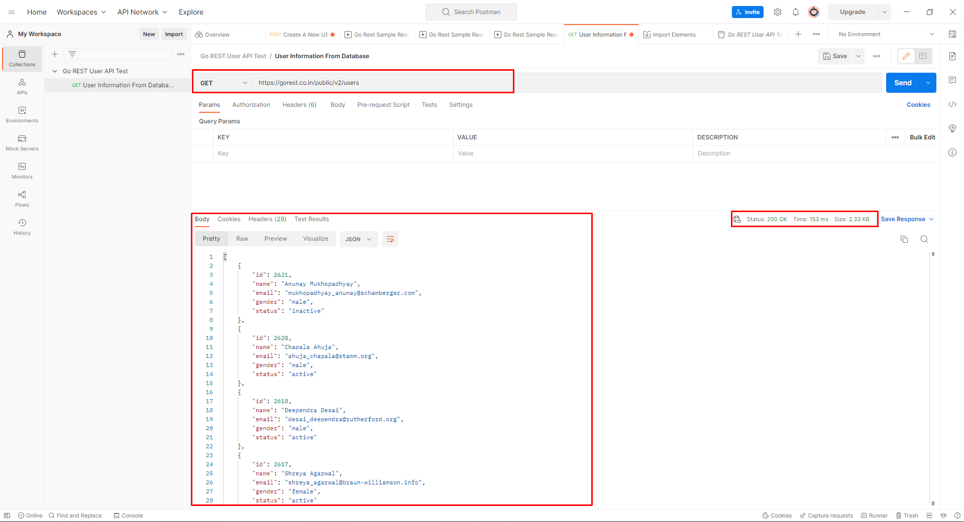

Test Request Method : GET

Response Code : 200 with Body Massage

**Test Result: Passed**

**Test Report:**

I used Newman for Test Report. Results of API testing are well understood through Newman

Given Postman testing image:

